Payment Instruction Sheet

Once you have received an invoice for a MIIC program, you will need to pay using a bank transfer. If you would like to pay in Czech Crowns (CZK), you can make a simple transfer through a Czech bank account.

If you would like to pay in American dollars (USD)/from an American account, you will need to make an international bank transfer.

This packet will guide you in making an international payment to pay for a MIIC program.

Common questions

How do I make an international bank transfer?
You have 2 options to make an international bank transfer:

- Make a standard wire transfer through your bank. Depending on the bank, you may have to go in-person to do this. The cost of an international wire transfer can incur fees from between $20 to $50.
  - If you are paying in installments (a deposit and then the remaining balance), these fees can add up; if you prefer to pay using a wire transfer through your bank, we would recommend paying the entire amount at once so you don’t have to pay this fee multiple times.
  - You can use the information on the invoice to make this wire transfer. If you have any difficulties, a banker will likely be able to help you.
  - Make sure that MIIC receives the total amount of the invoice; the fee to make a wire transfer is NOT included in the cost of tuition.
- Make an international bank transfer using an online service, such as Wise or Revolut. These services usually charge lower fees and you can set up an account and make payments online or using the app.
  - See below for tutorials on how to use these services to pay an invoice.
  - If you are using an alternative service, please ensure that the service accepts commercial payments/allows you to pay invoices. XOOM (PayPal), for example, cannot be used to make commercial payments!

Can I pay by card, cash, or check?

Unfortunately, we cannot currently accept card payments for our programs. There are some additional costs (for example, additional accommodation costs that are not included in tuition fees) that may be paid by card in the case that the payment is not to us but rather to another business that accepts card payments (e.g. Hotel Krystal).
Czech banks do not offer a way to cash checks, so we cannot accept checks. For large payments (such as tuition for programs), we don’t allow cash payments on arrival because we need to make reservations and deposits ahead of the program.

How to Pay through Wise

- Go to wise.com or download the app and create an account using the sign up button in the top right corner.
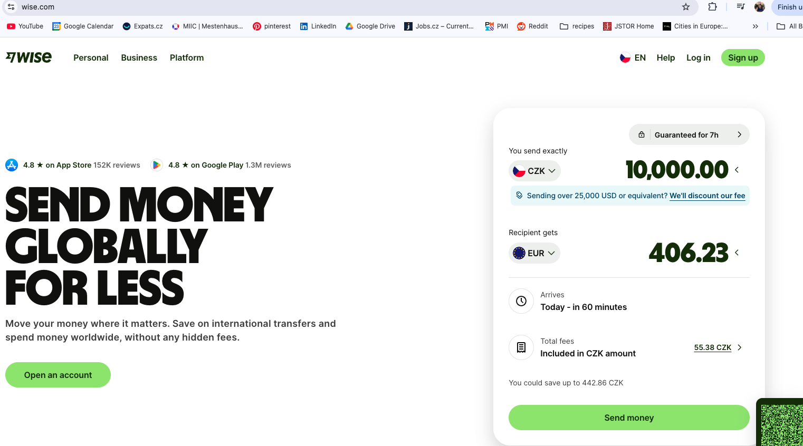

- Once you’ve made an account, click SEND
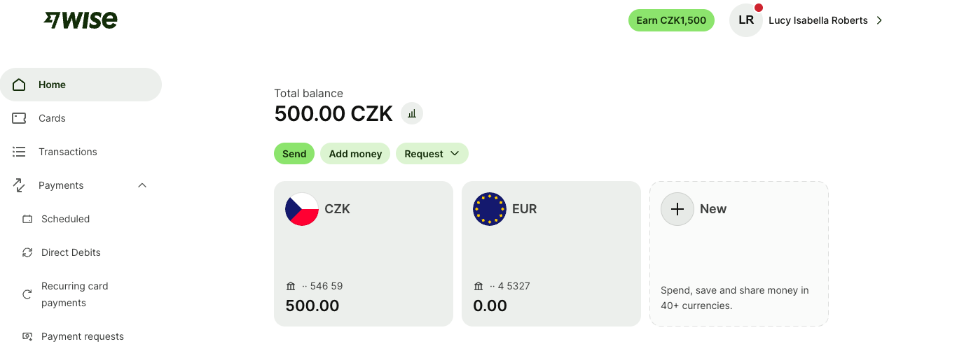

- Click on UPLOAD and upload the invoice for your program.
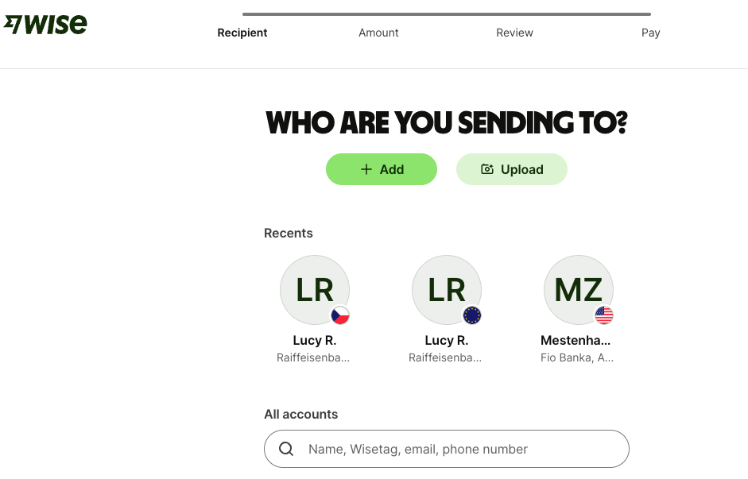

- If a currency is not already selected, select the currency USD
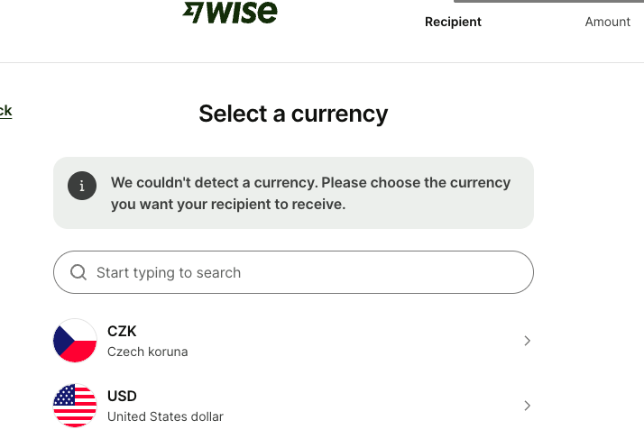
- Ensure that the account type is BUSINESS, and check the information from the invoice has been correctly imported. You can make a SWIFT payment using the information on the invoice.
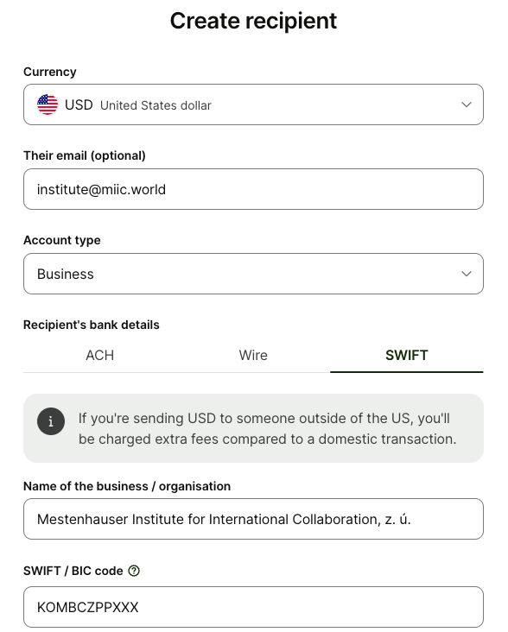

- You can also pay by ACH transfer using the ROUTING NUMBER and and the ACCOUNT NUMBER
  - IBAN: CZ5920100000002703263412 BIC: FIOBCZPPXXX

- Fill in the section "Recipient gets” FIRST with the exact amount listed on the invoice. This is crucial as it will ensure that your entire balance is paid and that the fees for payment has not come out of the amount we receive. You can add a reference to write the student you are paying for.
  - The image below is how your payment should look: the YOU SEND section should include the fee. Note that this fee (10.82) will vary based on the current exchange rate but will still likely be much cheaper than the wire transfer fee through your bank.
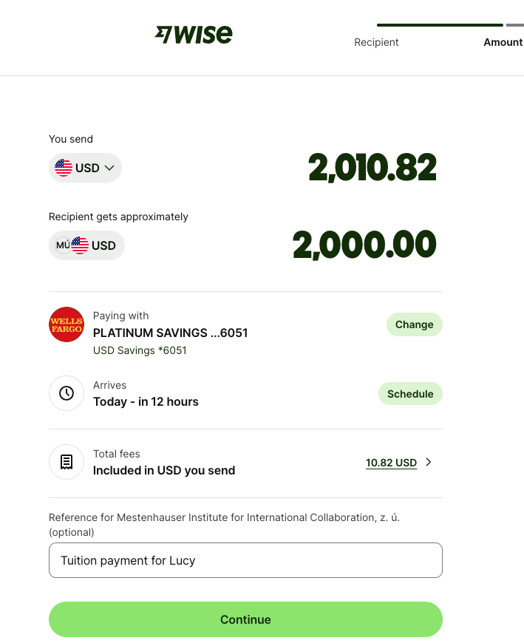
- Select the reason for transfer as “Pay for Goods and Services”
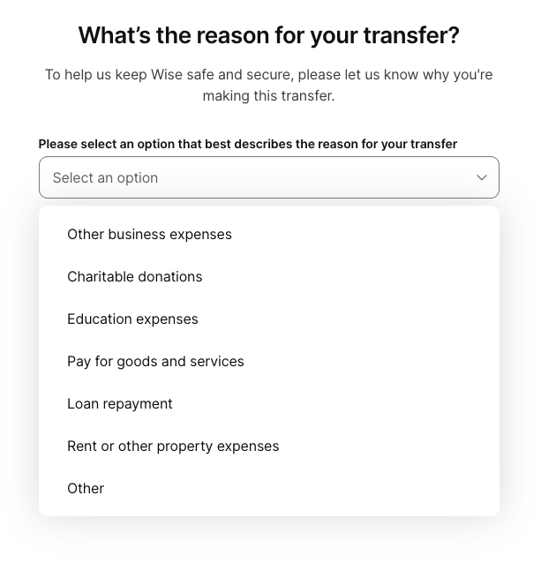
- Review payment details and click “send now”.

How to Pay through Revolut

- Go to revolut.com and click sign up or download the app and follow the sign up process.
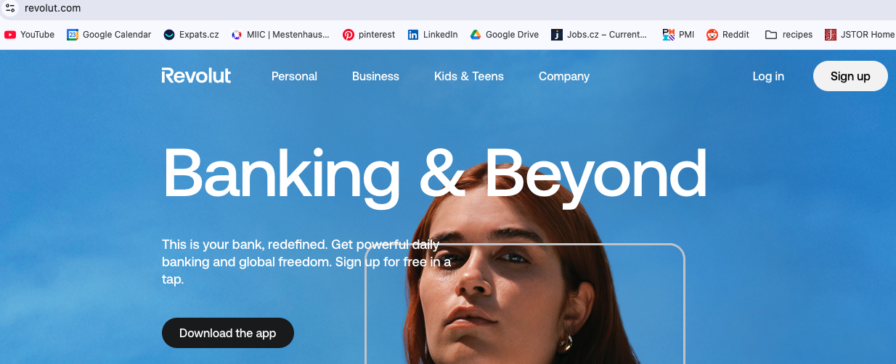
- In the app, select Payment in the bottom bar.
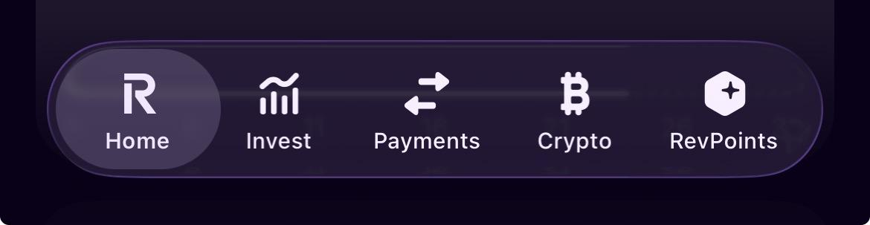

- Select INTERNATIONAL
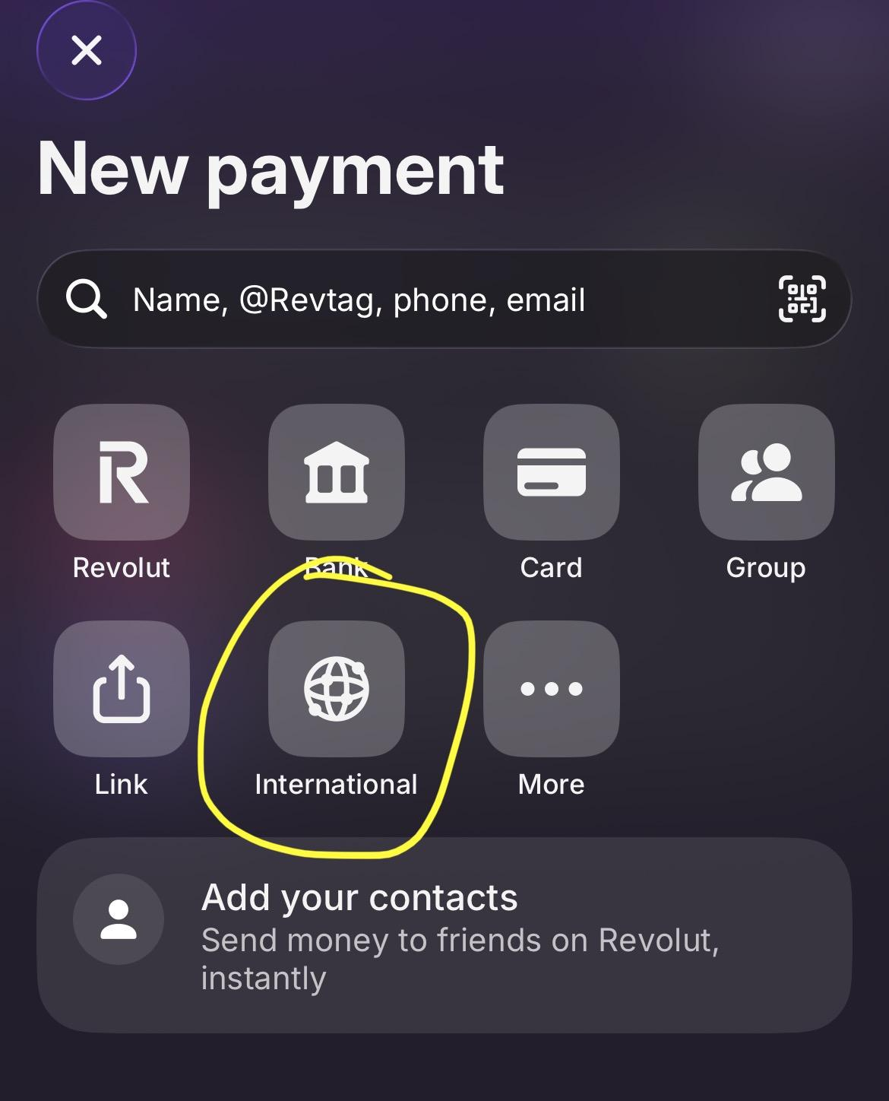
- Select destination as CZECHIA
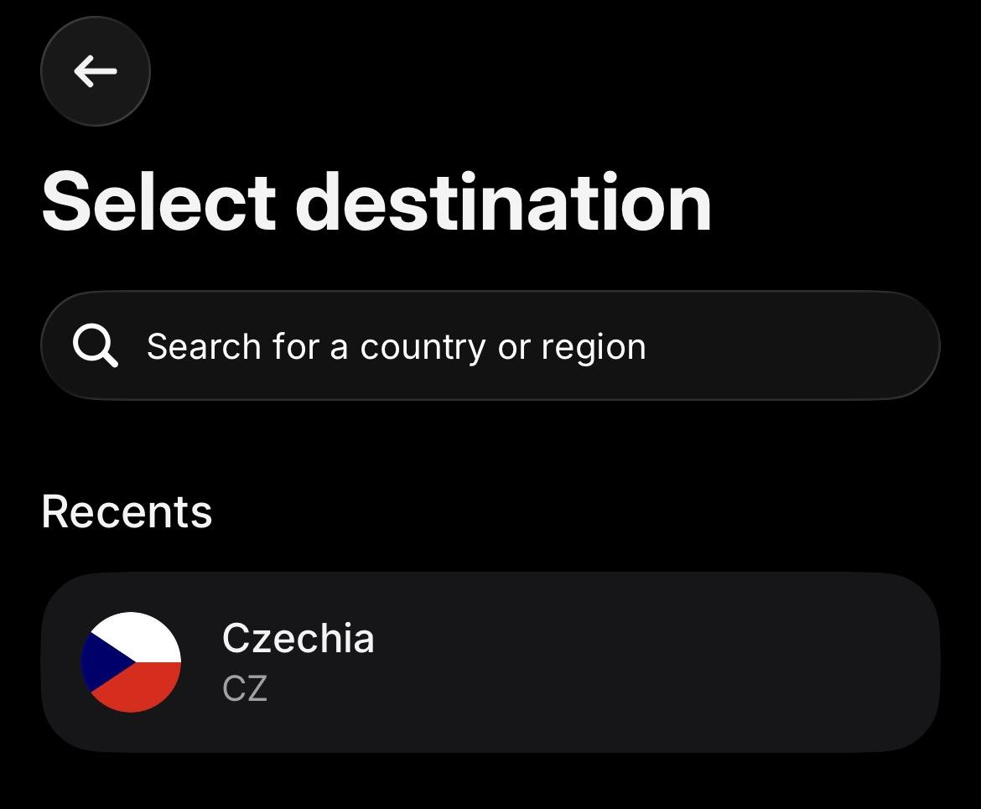

- Put in the full amount you have been invoiced for and add a reference. 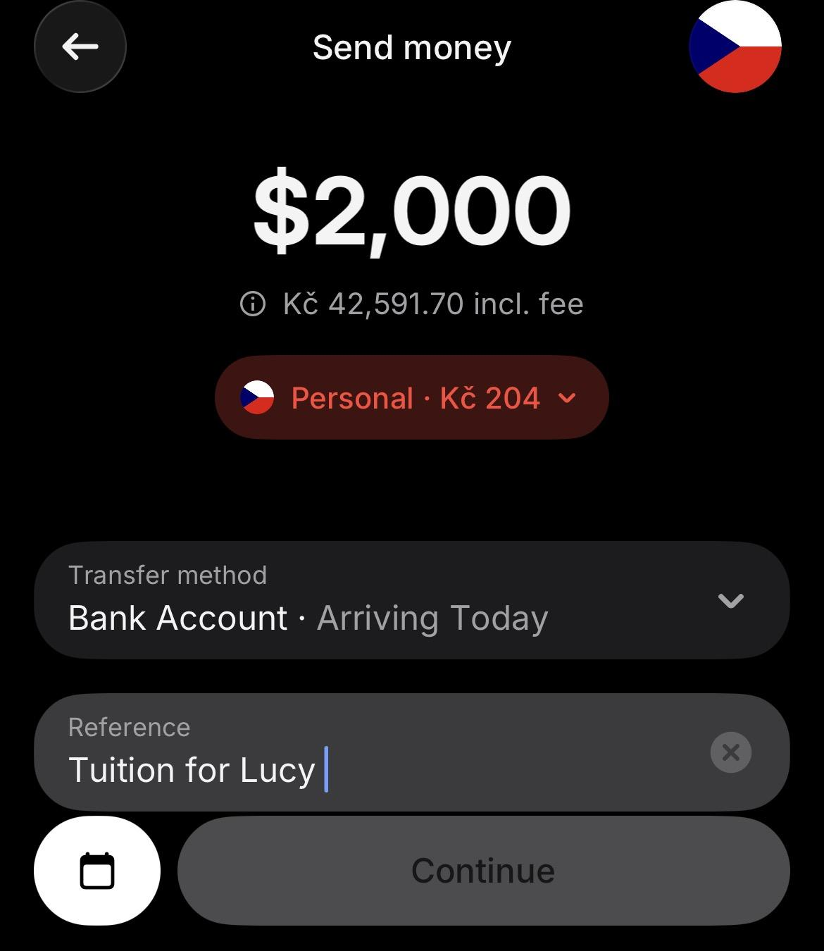

- Add a BUSINESS recipient and fill in the information based on the invoice.
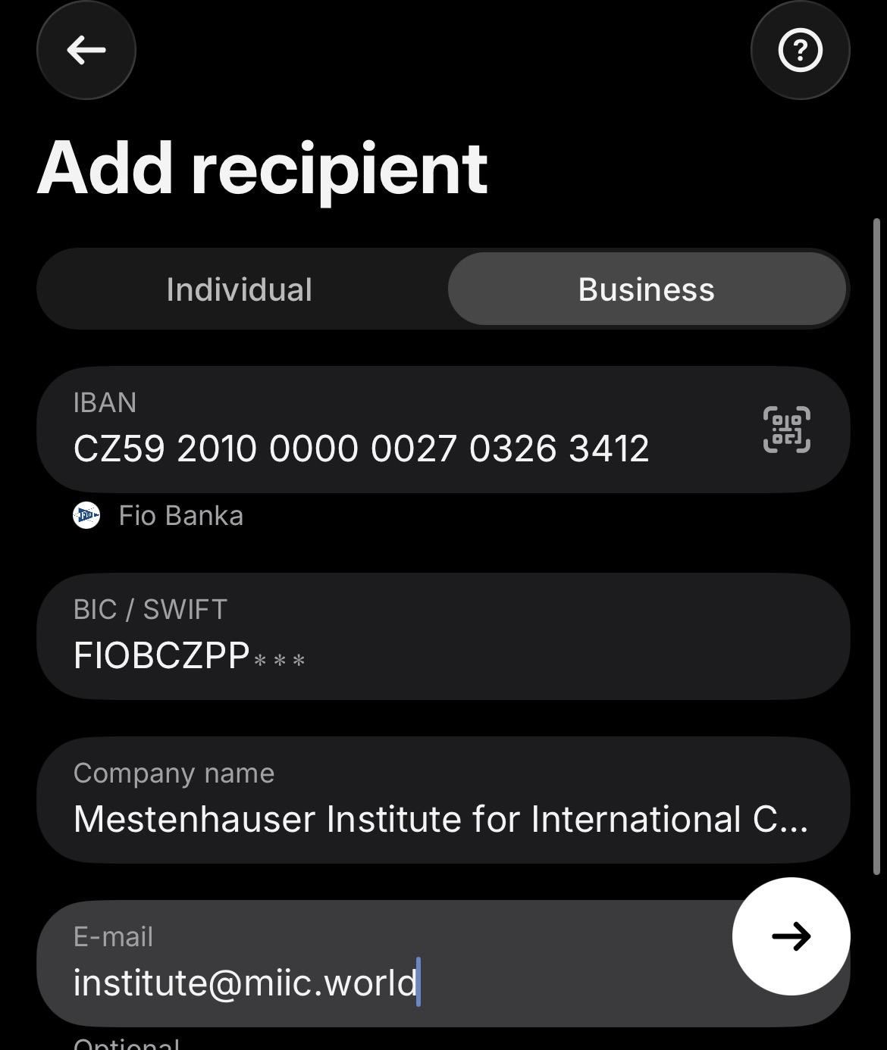

- Fill in address details using the information on the invoice.
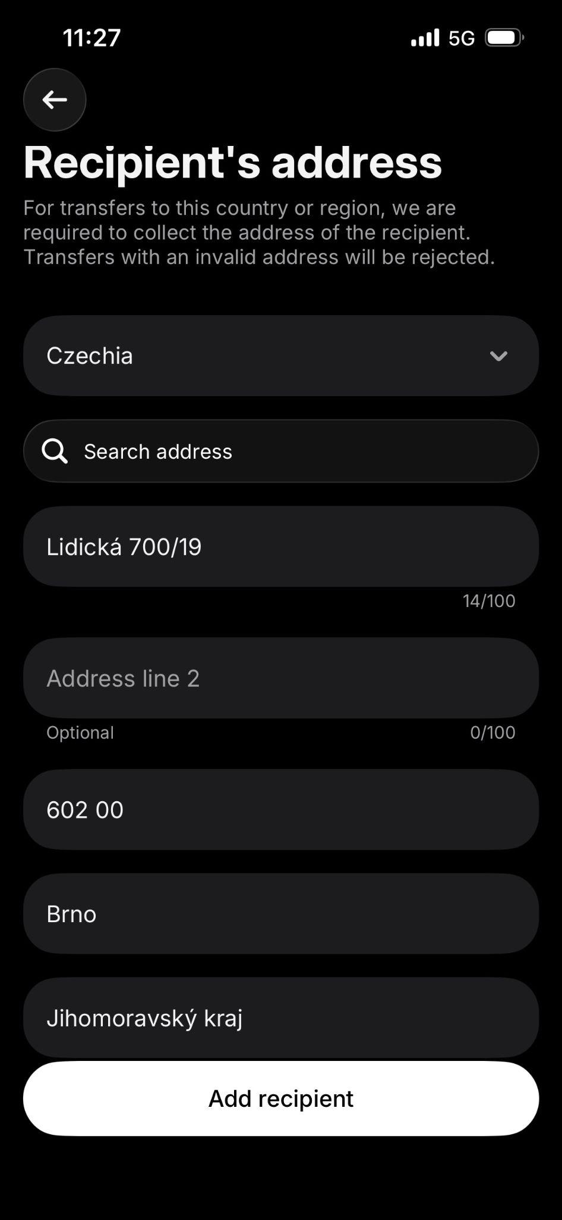

- Check the details again and confirm the payment.

